Pokhara University

Level: Bachelor | Semester – Fall | Year : 2009
Programme: Architecture |  | Full Marks : 100
Course: Mathematics II |  | Time : 3hrs.

Candidates are required to give their answers in their own words as far as practicable.
The figures in the margin indicate full marks.

Attempt all the questions.

1. | - State and prove Cauchy's root test for the convergence of an infinite series of positive terms.  - Test the convergence of the following series: 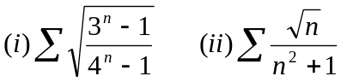 | 7  8
2. | - Show that the infinite series u₁-u₂+u₃-u₄+u₅……………………  In which the terms are alternately positive and negative, is convergent if each term is numerically less than the preceding term and 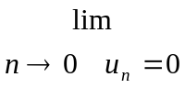  - Find the interval and radius of convergence of the infinite series:  | 7  8
3. | - Use vector method to show: Cos(A-B)=CosA.CosB+SinA.SinB  - Define scalar triple product of vectors. Find the volume of a parallelepiped whose concurrent edges are: | 7  8
4. | - Show that for any three vectors: 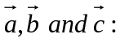 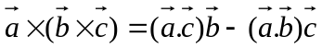  - Show that the four points having position vectors:are coplanar. | 7  8
5. | - Solve: 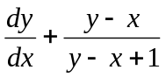.  - State the condition for exactness of the differential equation: M dx+N dy = 0 where M and N are functions of X and y. and show that: (xy⁴+y²)dx+2(x²y³+xy+y⁵)dy = 0 is exact and hence solve it. | 7  8
6. | - Solve: 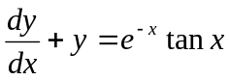  - Solve: 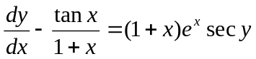  OR  Solve: 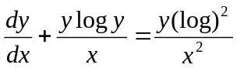 | 7  8
7. | Short questions:  - Show that: 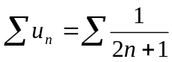is divergent.  - Show that: 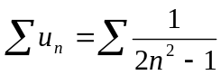is convergent.  - Find integration factor of: 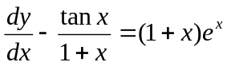  - Find the arc of parallelogram whose sides represent: 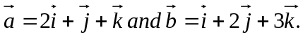  - Solve: (1+x)dy-1(1+y)dx = 0. | 5×2

